EX NO: 1 – IDENTIFIES A SOFTWARE SYSTEM THAT NEEDS TO BE DEVELOPED
PROJECT TITLE: Airline Reservation System
OBJECTIVE:
The objective of this project is to develop an Airline Reservation System (ARS) that enables efficient management of flight schedules, passenger bookings, seat allocation, and ticket generation. The system is designed using Object-Oriented Software Engineering concepts to ensure modularity, scalability, and maintainability.
PROBLEM STATEMENT:
Airline companies often face challenges in managing flight reservations, seat availability, passenger records, and ticket cancellations using manual or fragmented systems. These issues can result in booking errors, overbooking, delayed ticket processing, and poor customer experience. This project aims to develop a user-friendly, reliable, and automated Airline Reservation System that reduces manual effort and improves operational efficiency.
SCOPE OF THE SYSTEM:
- User authentication (Admin, Airline Staff, Passenger)
- Flight management (Add, Update, Delete flight details)
- Passenger registration and profile management
- Ticket booking and seat allocation
- Ticket cancellation and refund processing
- Fare calculation and payment handling
- Report generation (Booking details, Flight occupancy, Revenue reports)

RESULT:
Thus, the implementation of the Airline Reservation System was successfully completed, and its objective, problem statement, and scope were clearly defined.
EX NO: 2 – DOCUMENT THE SOFTWARE REQUIREMENTS SPECIFICATION (SRS)
PROJECT TITLE: Airline Reservation System
MODEL USED: Spiral Model
PROJECT DESCRIPTION:
The Airline Reservation System (ARS) is a web-based application used to manage airline operations such as flight scheduling, passenger booking, ticket cancellation, and seat allocation. It helps automate the reservation process, reduces manual errors, improves efficiency, and provides a convenient platform for users to book and manage flight tickets online.
1. INTRODUCTION
The Software Requirement Specification (SRS) document describes the requirements of the Airline Reservation System (ARS). This document is prepared based on IEEE 830 standards to identify, analyze, and define both functional and non-functional requirements of the system. It serves as a reference for designing and implementing the system using web technologies and object-oriented concepts.
1.1 PURPOSE
The Airline Reservation System (ARS) is designed to automate airline operations such as flight scheduling, passenger management, ticket booking, and cancellation. The system aims to improve booking accuracy, reduce manual effort, and enhance customer experience.

1.2 SCOPE
- Allows passengers to search flights, book tickets, and cancel reservations
- Provides admin functionalities for managing flights, fares, and schedules
- Enables seat allocation and ticket generation.
- Generates reports on bookings, flight occupancy, and revenue.
- Ensures secure access through user authentication.

1.3 DEFINITIONS, ACRONYMS, AND ABBREVIATIONS
- ARS – Airline Reservation System
- Admin – Airline administrator with full system control
- Passenger – User who books and manages flight tickets
- Flight – Scheduled air travel between two locations
1.4 REFERENCES
- IEEE 830-1998 standard for Software Requirements Specification
- Unified Modelling Language (UML) diagrams
2. OVERALL DESCRIPTION
2.1 PRODUCT PERSPECTIVE
The Airline Reservation System is a standalone web-based application that manages flight schedules, passenger bookings, and ticket transactions.
2.2 PRODUCT FUNCTIONS
- Passenger Registration & Login
- Flight Search and Schedule Management
- Ticket Booking and Seat Allocation
- Ticket Cancellation and Refund Processing
- Fare Calculation and Payment Handling
2.3 USER CHARACTERISTICS
- Admin – Manages flights, fares, schedules, and reports.
- Passenger – Searches flights, books tickets, and manages reservations.
- Airline Staff – Assists passengers and monitors booking status.

2.4 CONSTRAINTS
- The system must comply with airline booking rules and regulations.
- Maximum number of seats per flight is fixed and cannot be exceeded.
- Online payment depends on third-party payment gateways.

3. SPECIFIC REQUIREMENTS
3.1 FUNCTIONAL REQUIREMENTS
3.1.1 USER AUTHENTICATION
- The system shall allow users to register and log in using valid credentials.
3.1.2 FLIGHT MANAGEMENT
- The system shall allow the admin to add, update, and delete flight details.
3.1.3 TICKET BOOKING
- The system shall allow passengers to book tickets based on seat availability.
3.1.4 TICKET CANCELLATION
- The system shall allow passengers to cancel booked tickets and process refunds.

3.2 NON-FUNCTIONAL REQUIREMENTS
- The system shall support up to 500 concurrent users.
- The response time shall be less than 2 seconds for booking operations.
- The system shall ensure data security and user privacy.

3.3 INTERFACE REQUIREMENTS
HARDWARE INTERFACES
- User Device (Computer / Laptop / Mobile) – used by passengers and admin to access the System.
- Application Server – runs the Airline Reservation System application.
- Database Server – stores flight, passenger, and booking data.
- Network (Internet) – enables communication between users and the system.
SOFTWARE INTERFACES
- Airline Reservation Application – main system that manages flight booking and operations.
- Admin Module – manages flights, fares, schedules, and reports.
- Passenger Module – allows users to search flights, book tickets, and cancel reservations.
- Payment Gateway Module – processes online payments securely.
- Authentication Module – handles user login and security.
DATABASE INTERFACES
- Flight Database – stores flight details and schedules.
- Passenger Database – stores user details and login information.
- Booking Database – stores ticket booking and cancellation details.
- Payment Database – stores transaction and payment status.

RESULT:
Thus, the Software Requirement Specification (SRS) for the Airline Reservation System was successfully prepared using the Spiral Model, and all system requirements were clearly identified and documented for Java-based implementation.
EX NO: 3 – IDENTIFY USE CASES AND DEVELOP THE USE CASE MODEL

PROJECT TITLE: Airline Reservation System

DESCRIPTION:
- A Use Case Diagram is used to represent the interaction between actors and system functionalities in the Airline Reservation System.
- It helps in identifying the functional requirements of the system clearly.
The main actors identified are Admin, Passenger, and Airline Staff.
- The Admin performs use cases such as Login, Manage Flights, Update Schedules, Set Fares, and Generate Reports.
- The Passenger performs Register/Login, Search Flights, Book Tickets, Cancel Tickets, and View Booking Details.
- The Airline Staff performs Check Passenger Details, Monitor Bookings, and Assist in ticket processing.
- Each use case represents a specific function provided by the system.
- The relationships between actors and use cases define the overall system behavior.
- The diagram helps in understanding the interaction flow and supports further system design.

USECASE DIAGRAM:
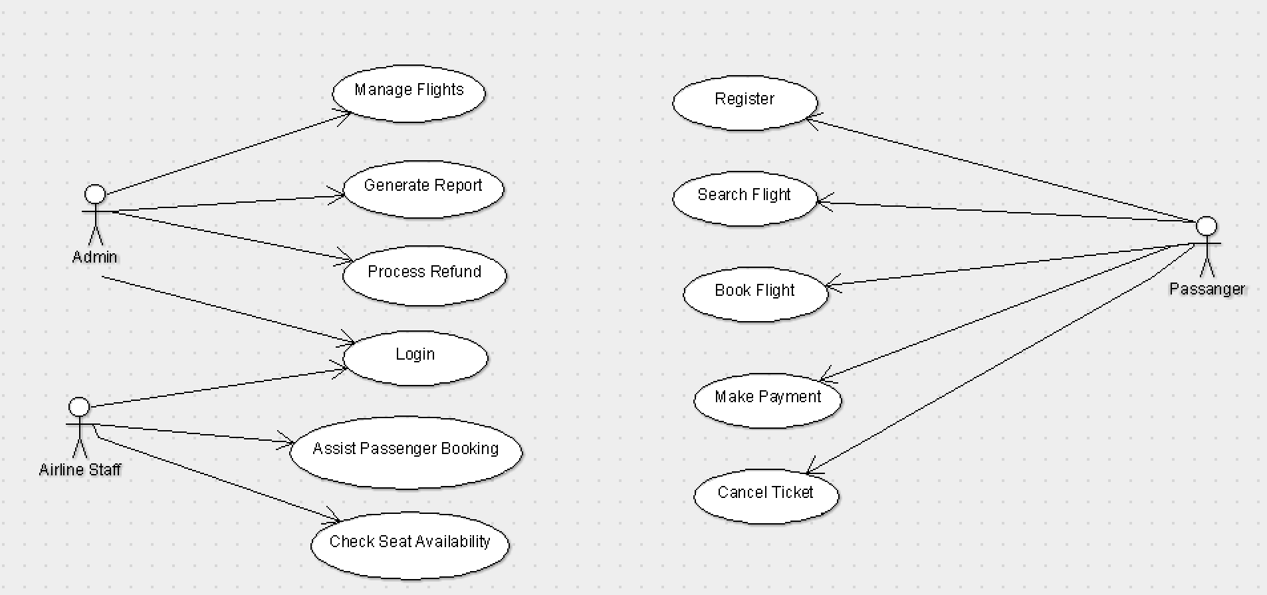

RESULT:
Thus, the use cases such as Register/Login, Manage Flights, Update Schedules, Set Fares, Generate Reports, Search Flights, Book Tickets, Cancel Tickets, View Booking Details, and Monitor Bookings were successfully identified, and the Use Case Model was developed using ArgoUML for the Airline Reservation System.
EXP NO : 4 - IDENTIFY THE CONCEPTUAL CLASSES & DEVELOP A DOMAIN MODEL AND ALSO DESIGN CLASS DIAGRAM FROM THAT

PROJECT TITLE: Airline Reservation System
DESCRIPTION:
- The Domain Model represents the real-world entities and their relationships in the Airline Reservation System.
- The System (ARS) manages overall operations such as login, booking, cancellation, and report generation.
- User is a general class representing all users of the system.
- Admin manages flights, schedules, and generates reports.
- Passenger searches flights, books tickets, and cancels reservations.
- Flight contains flight information such as source, destination, schedule, and seat availability.
- Booking stores booking details including seat number, booking status, and date.
- Payment handles payment transactions and refund processing.
- These classes interact with each other to provide a complete airline reservation system.

CLASS DIAGRAM:
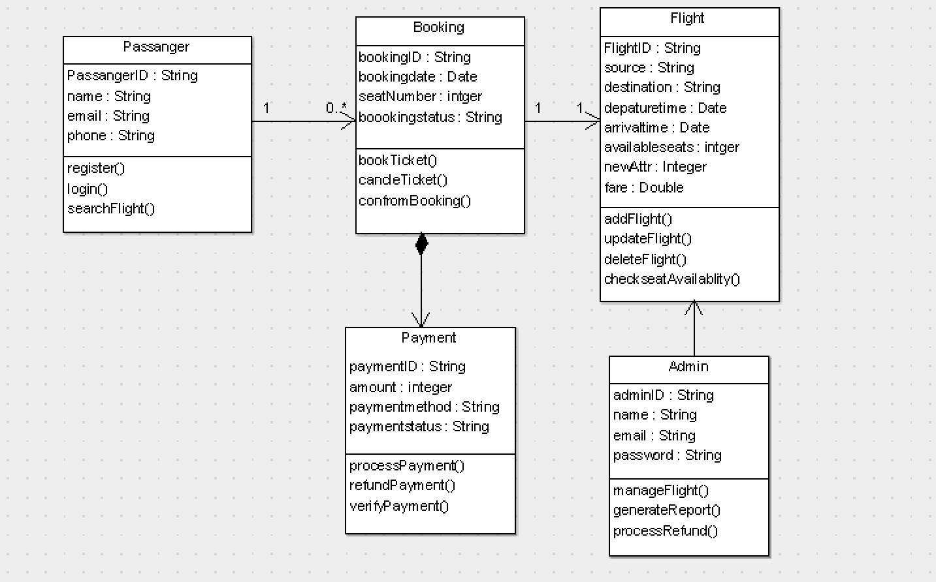

RESULT:
Thus, the conceptual classes were identified, and the Domain Model and Class Diagram for the Airline Reservation System were successfully developed.
EX NO: 5 - USING THE IDENTIFIED SCENARIOS FIND INTERACTIONS BETWEEN OBJECTS AND REPRESENT THEM USING UML SEQUENCE AND COLLABORATION DIAGRAM
PROJECT TITLE: Airline Reservation System
DESCRIPTION - SEQUENCE DIAGRAM:

- A Sequence Diagram represents the interaction between objects in a time-ordered manner.
- It shows how messages are passed between objects step by step.
- In the Airline Reservation System, the main objects are Passenger, System, Flight, Booking, and Payment.
- The Passenger initiates the process by sending a login request to the system.
- The system verifies the user credentials and allows access.
- The Passenger searches for available flights using searchFlight().
- The system retrieves flight details from the Flight object.
- The Passenger selects a flight and sends a booking request using bookTicket().
- The system checks seat availability and processes payment using processPayment().
- The booking is confirmed and the ticket is generated using generateTicket().
- This diagram clearly shows the sequence of operations from login to ticket confirmation.

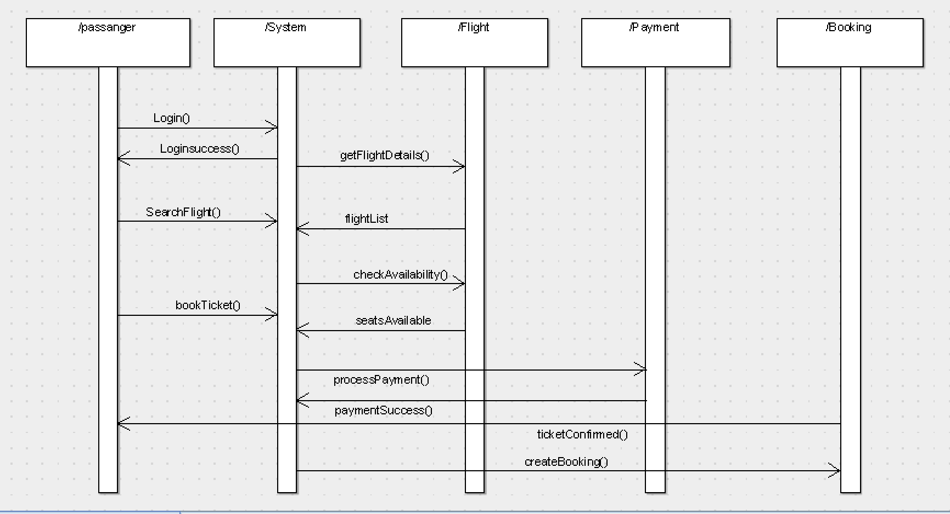

DESCRIPTION – COLLABORATION DIAGRAM
- A Collaboration Diagram represents the interaction between objects using message flow and numbering.
- It focuses on how objects are connected and communicate with each other.
- In the system, objects such as Admin, Passenger, Flight, Booking, and Payment are involved.
- The Admin interacts with the system to manage flight schedules and data.
- The Passenger interacts with the system to search flights, book tickets, and cancel reservations.
- The Flight object provides flight details and seat availability.
- The Booking object connects Passenger and Flight to manage reservations.
- The Payment object handles payment processing and refunds.
- Message numbers indicate the order of execution and relationship between objects.

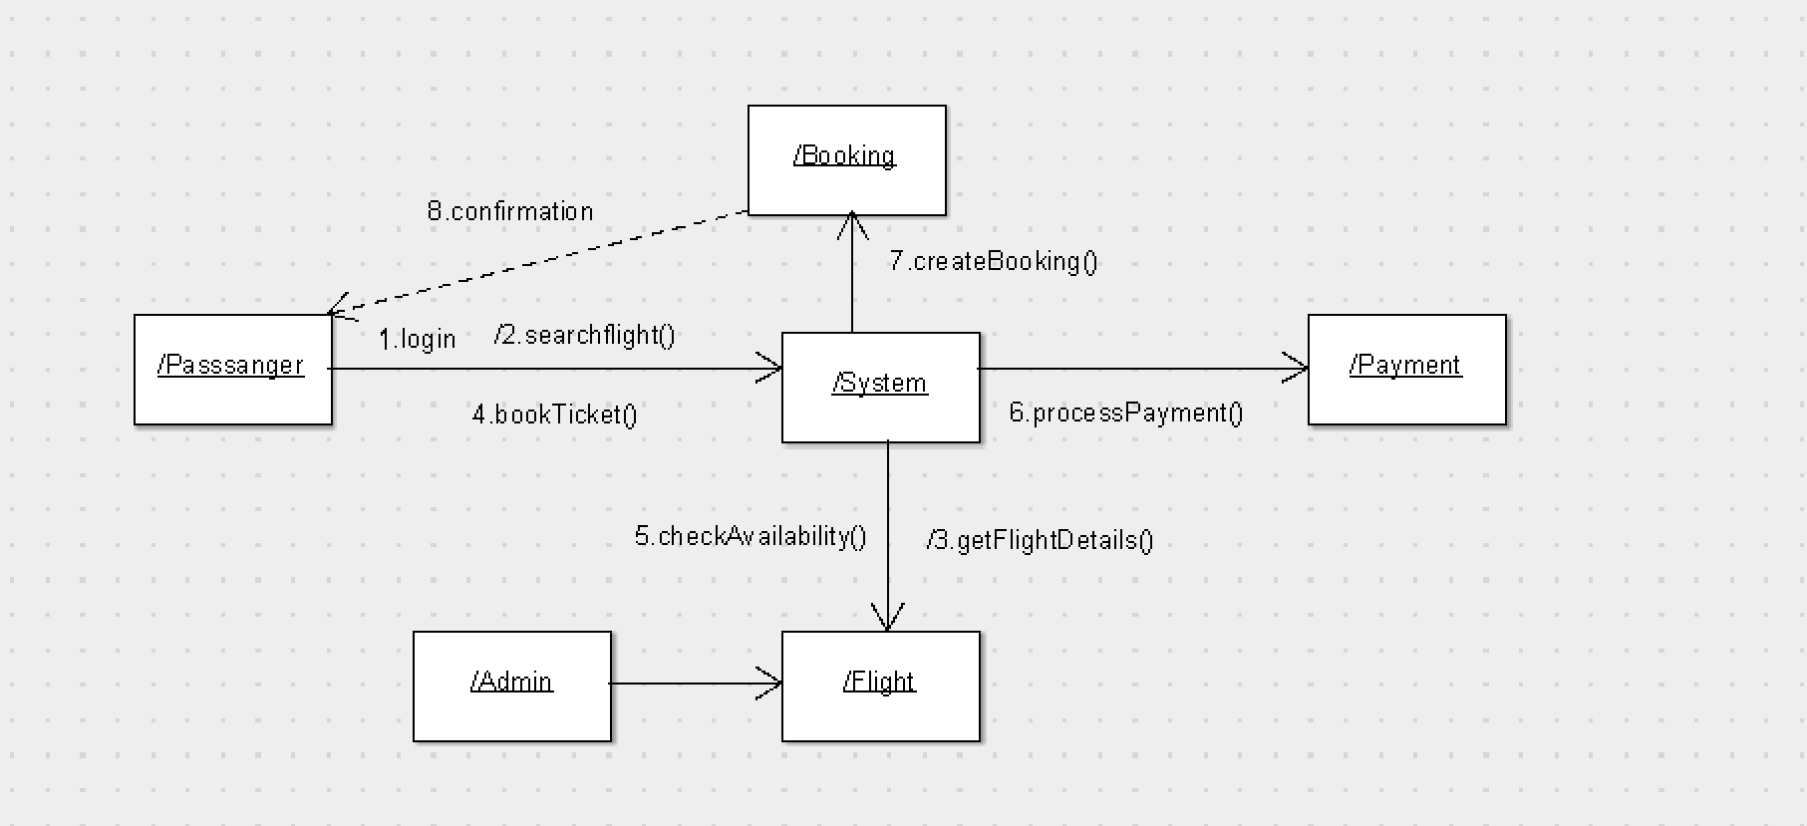

RESULT:
Thus, the interaction between objects in the Airline Reservation System was successfully identified and represented using both Sequence and Collaboration Diagrams.
EXP NO: 6 - DRAW RELEVANT STATE CHART AND ACTIVITY DIAGRAMS FOR SAME SYSTEM
Project Title: Airline Reservation System
DESCRIPTION – ACTIVITY DIAGRAM
- An Activity Diagram represents the workflow of the system and shows the sequence of activities.
- It describes how different operations are performed from start to end.
- In the Airline Reservation System, the process starts when the Passenger logs into the system.
- The system verifies the user credentials using a decision (valid/invalid).
- If valid, the Passenger searches for available flights.
- The Passenger selects a flight and proceeds to book the ticket.
- The system checks seat availability before booking.
- The system processes the payment using payment processing.
- If payment is successful, the ticket is confirmed.
- Finally, the process ends after booking confirmation or logout.

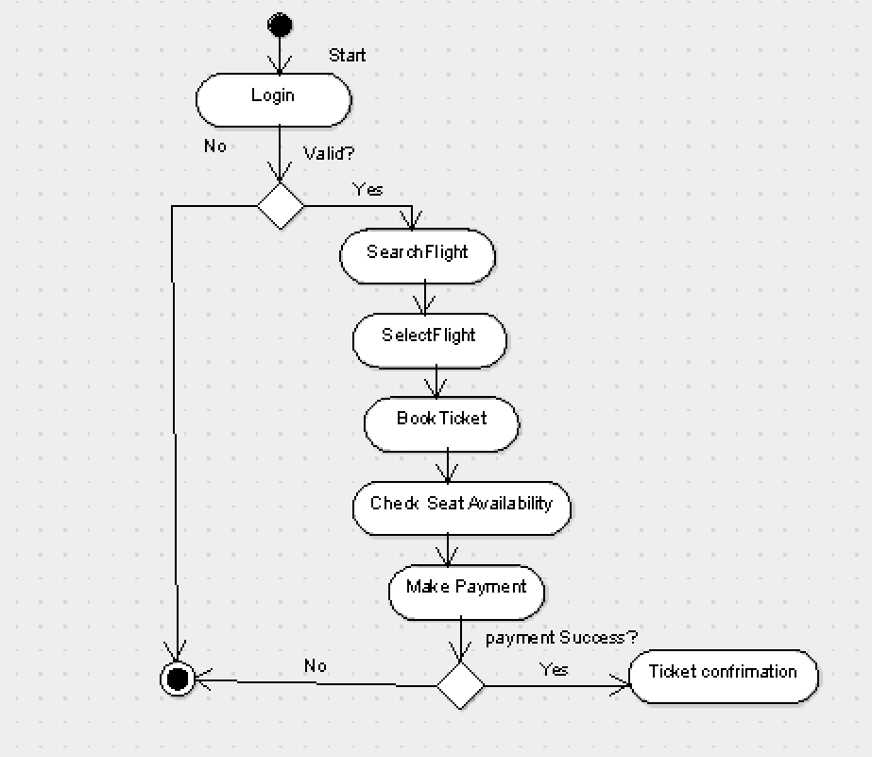
DESCRIPTION – STATE CHART DIAGRAM
- A State Chart Diagram represents the different states of an object during its lifecycle.
- It shows how the system changes from one state to another based on events.
- In this system, the Passenger moves through various states.
- The process starts with Logged Out state.
- After successful login, it moves to Logged In state.
- Then it enters Flight Search state to search flights.
- Next, it moves to Flight Selection state after choosing a flight.
- The system then enters Booking state to initiate ticket booking.
- After that, it moves to Payment Processing state.
- If payment is successful, it reaches Ticket Confirmed state.
- The Passenger may also enter Cancellation state if needed.
- Finally, the system reaches Logout/End state.
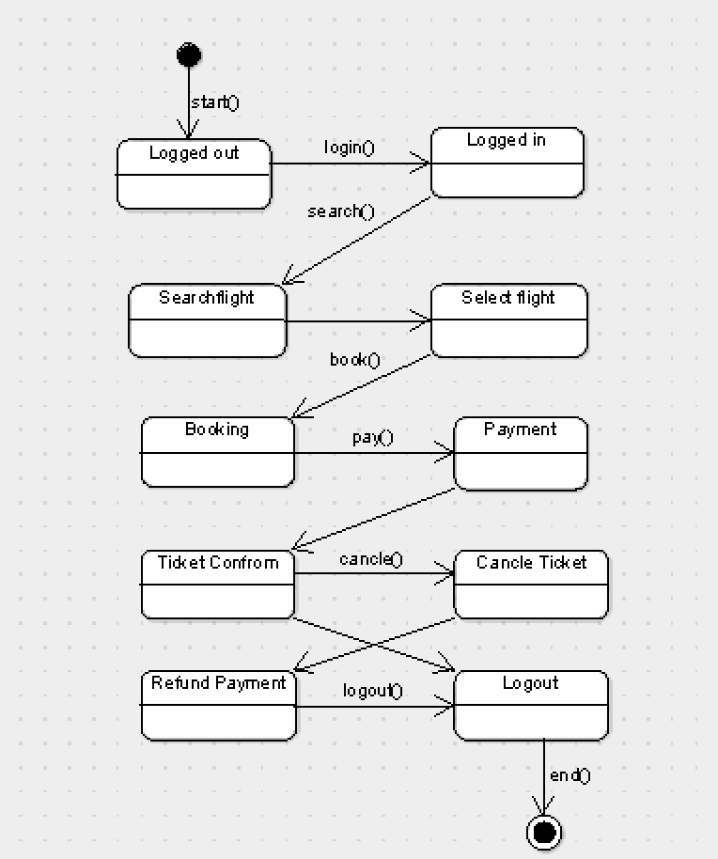
DESCRIPTION – DEPLOYMENT DIAGRAM
- A Deployment Diagram represents the physical architecture of the system including hardware components and software modules.
- It shows how different devices and modules are connected and communicate with each other.
- In the Airline Reservation System, the main components are Client Device, Web Server, Application Server, and Database Server.
- The Client Device is used by Passenger/Admin to access the system through a web or mobile application.
- The Web Server handles user requests and provides the user interface.
- The Application Server processes booking, payment, and business logic of the system.
- The Database Server stores flight details, passenger data, and booking records.
- All components communicate through a network to ensure smooth data flow and system operation.

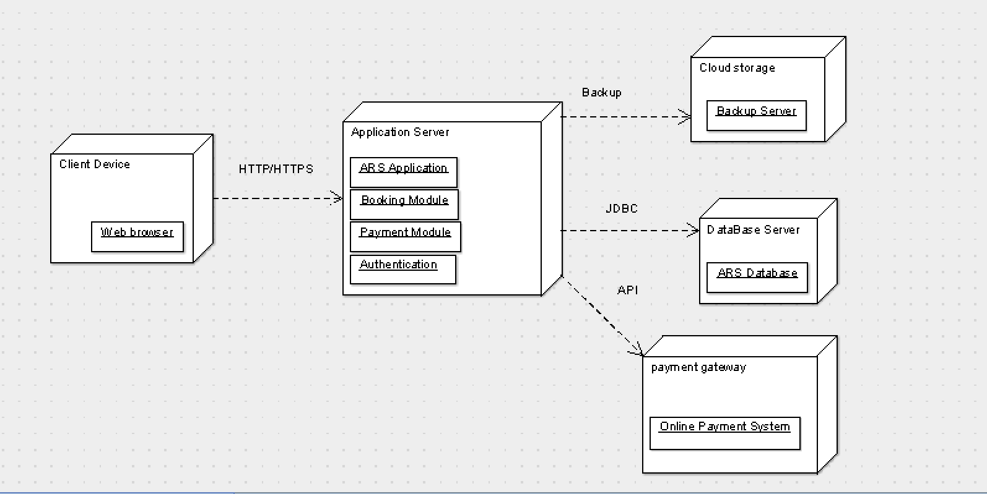
RESULT:
Thus, the Activity Diagram and State Chart Diagram for the Airline Reservation System were successfully developed to represent the workflow and state transitions of the system.

